1. **ESSAY (50%)**
2. **(15%)** On requirement engineering process, the most common activities are inception, elicitation, elaboration, negotiation, specification, and validation. Explain what would happen if the elaboration process is ignored and give at least one example! Provide your answer in less than 100 words.

**Answer (99 Words):**

Elaboration Phase expands the requirements defined in the previous two steps into a technical model of the software and its functions. If we miss this task it would create unfeasible goals rather than as true requirement. Let us consider example what happen if we skip Elaboration Phase , in Online OTP system that required only 10k message/day. Elaboration phase evaluate how much message required by OTP system on daily basis. If skipped this phase, Negotiation become very difficult because daily message requirement is not cleared at Negotiation phase. In such way that complete project development process get become complex.

1. **(15%)** Two of the most commonly used Software Process Models are Waterfall Model and Agile Model. Compare the pros and cons of each process model when the team is faced with a quarantined situation like you are currently facing and must work remotely from home!

**Answer :**

**Pros of Waterfall Model :**

1. Simple and Easy to understand and use
2. Easy to manage due to rigidity of the model
3. Phases are processed and completed one at a time
4. Works well for smaller projects
5. Clearly defined stages
6. Well understood milestones
7. Easy to arrange task
8. Process and Result are well documented

**Cons of Waterfall Model :**

1. No working software is produced until late during the life cycle
2. High amount of risk and Uncertainity.
3. Not a good model for complex projects
4. Not suitable for projects where requirements are at high risk of changing
5. It is difficult to measure progress within stages
6. Cannot accomodate changing requirements'
7. Adjusting scope during the life cycle can end a project

**Pros of Agile Model :**

1. Better time to market
2. Increase market share and bigger profit
3. Reduced cost for bug fixing
4. Improved software quality
5. Increased employees productivity & satisfaction
6. Customer Satisfaction

**Cons of Agile Model :**

1. Vague hierarchy and blurred organizational structure
2. Incapability to perform regression testing
3. Inflexibility to changing requirements
4. Poor communication within a team
5. Inability to estimate the lead time
6. **(10%)** There are four modelling schemes in requirement modelling that can be chosen upon performing requirement analysis, which are: scenario-based models, class models, behavioral models, and flow models. Explain the justification for choosing each model!

**Answer :**

1. **Scenario based models**

This type of model represents the system user point of view. **Scenario based model are use case diagram, user stories**.

1. **Class models**

The object of this type of model manipulated by the system. It defines the object attributes and relationship. The collaboration is occurring between the classes **Class model are the class diagram, collaboration diagram**.

1. **Behavioral models**

Behavioral models represent state of the system and how it is changed by the external events. The **behavioral model are sequenced diagram, state diagram**.

1. **Flow models**

An information flows through a computer-based system it gets transformed. It shows how the data objects are transformed while they flow between the various system functions. The **flow model are data flow diagram, control flow diagram**.

1. **(10%)** Explain your business idea for the final project as detail yet compact as possible, along with your targeted customer segment. Make sure to not exceed 200 words for your explanation.

**Answer (199 words):**

My Business idea name for the final project is “SMART CALENDAR”. Smart Calendar is an application that helps us to arrange meeting with friends and relatives based on your schedule. Why SMART CALENDAR? , because I expect that this application to help us become more disciplined in time, not to be late or in rush.

Our Feature of the App such as Merge in Calendar, like the name said, it is a calendar app with something more for people. That is a merge in system that can be used to display the availability of each person in a calendar. Chat Screen to hold a meeting with each other, there have to be clear communication and we offer a chat screen for that purpose. Description, It works as a note function to remind you about stuff needed for your meeting. GPS, It is clear already that GPS is used to show your location and your friends’ before a meeting.

My Customer Target from this idea is for all people who very much activities, so he/she will be helped by this idea, because this app schedule meeting, chat with client or friends online, share the location and others through the app.

1. **CASE (50%)**

PT PopLegal Indonesia is an IT Solution Company based in West Jakarta. Their core business is to provide online legal service in the form of digital legal contract and a marketplace for legal professionals like Advocates and Notaries. Currently they are using a web application as the main channel for their business process.

This company has over 50 staffs ranging from business, marketing, design, to IT professionals. Currently, their IT Product Division has 1 Engineering Manager, 2 System Analyst, 3 Programmer, 3 Senior Programmer, and 1 UI/UX designer. This division is currently using Waterfall Model as the basis for their software engineering process.

The company is looking to expand their platform to Mobile Application. The simple application will be aimed to provide legal consultation between users and legal professionals. The features of this application are: (1) choosing legal professionals either Advocate or Notary, (2) approval by the chosen professional, (3) chatting between the two parties, and (4) feedback for both parties.

Past assessment conducted in the end of 2019 by the Engineering Manager before his resignation shows that the company is lacking in performing tasks on time, since 37.21% of their overall tasks were overdue for 3 days or more. They are also lacking in quality assurance, since 100 errors are found for every 1000 lines of code (KLOC), while the common industrial average is 10 to 50 error per KLOC.

You are appointed as the new Engineering Manager for the company. As a new spirit eager in innovation and improvement, you have the opportunity to show your knowledge of software  
engineering in improving the productivity on the company, especially in the IT Product Division in both assisting with the new product development and with the internal improvement of your company productivity. Your preliminary assessment tells you that there is something wrong with the process model, that is the waterfall model that is currently used by the company.

1. **(20%)** When using the elevator, you met your CEO and you are eager to provide a short presentation on your method in improving the IT Product Division. Due to the limitation of time, you only have less than 5 minutes to pitch your strategy to the CEO. Your goal is to get the CEO to approve changing the software process model. Formulate your elevator pitch in less than 200 words!

**Answer (199 Words):**

**I am Glad to meet you sir. I am is to approve the changing the software process model. because we Changing the Platform form the Web application to the Mobile Application. So ideal Software model process for the Mobile Application is Agile Model. Due to Waterfall Model we are lacking in quality assurance, since 100 errors are found for every 1000 lines of code (KLOC), while the common industrial average is 10 to 50 error per KLOC**. **Our** **the company** **is lacking in performing tasks on time Gradually. I have analysed and found that 37.21%** of their **overall tasks were overdue for 3 days or more. If we want to expand the Mobile application with feature like choosing legal professionals either Advocate or Notary,approval by the chosen professional, chatting between the two parties, and feedback for both parties is unsuitable we are fail to made in Water fall model. So Please approve request for changing the software process model.**

As it will not only pace up our quality assurance but also reduces the error as per KLOC. So, to improve the company's productivity and mental strength of the employees , we should use Agile model instead of waterfall model.

1. **(10%)** To show a good example in the spirit of workplace improvement, you want to design the new product as mentioned in the 3rd paragraph above. Design the process with these diagrams: (1) Use Case Diagram and (2) Activity Diagram. Since the goal of this diagram is to be shown to higher-level management, make sure that your diagram is less technical and more conceptual.

**Answer :**

**USE CASE DIAGRAM :**

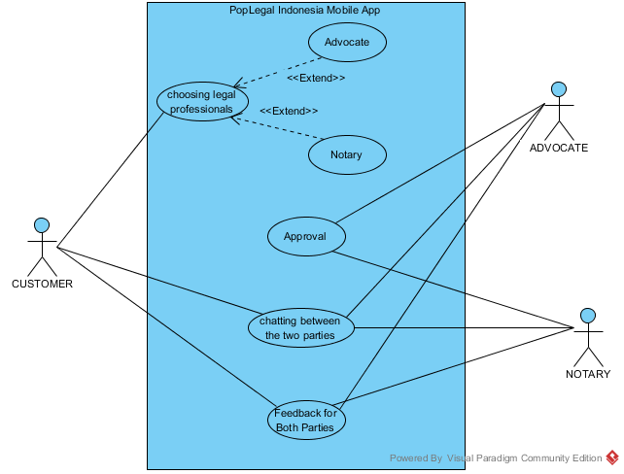

**ACTIVITY DIAGRAM (CHOOSING LEGAL PROFESSIONALS):**

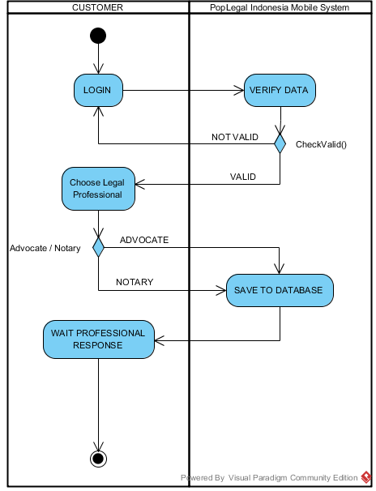

**ACTIVITY DIAGRAM (APPROVAL) :**

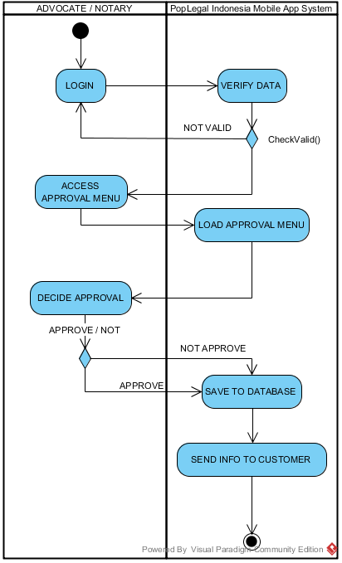

1. **(20%)** To provide further understanding to the stakeholder on the new product that will be developed, provide a UI design for every page that you will create. Make sure that you also provide a description for the UI design, so you are able to clearly communicate your design to anyone reading your documentation.

**Answer :**

1. **Main Menu Of the App**

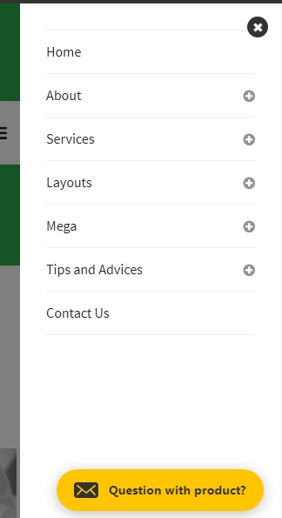

1. **Home Page**



1. **In About Menu, There Are 2 Sub-Menu**

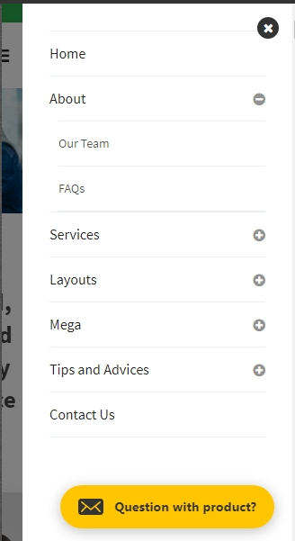

1. **OUR TEAM PAGE**

 

 

 

1. **FAQ PAGE**

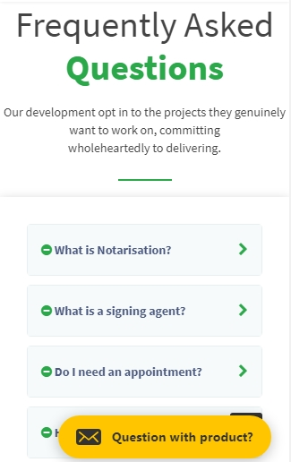

**When Click One of the FAQ, will Appear Like this :**

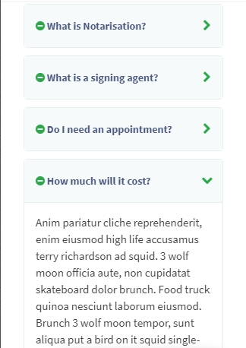

1. **SERVICE PAGE**

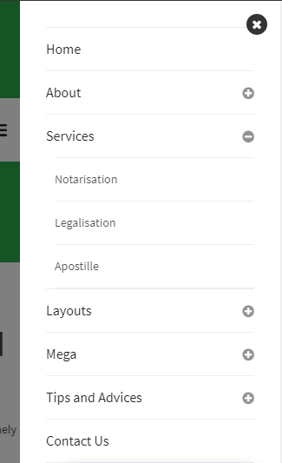 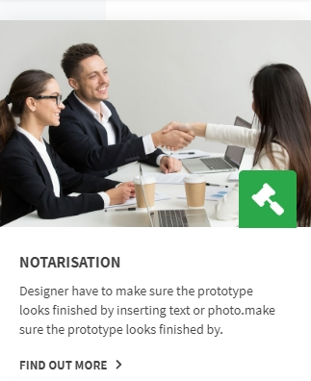

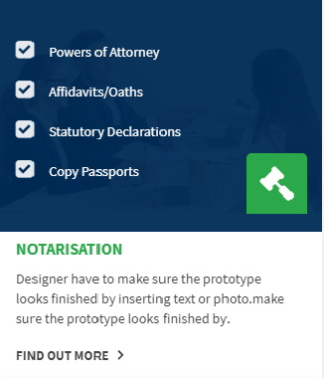 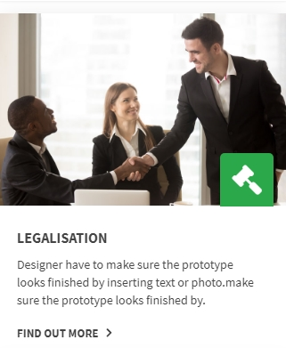

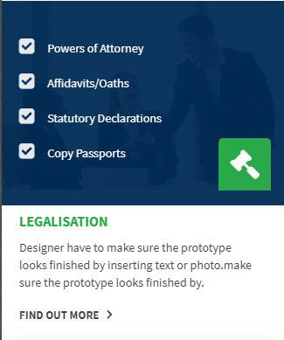

1. **WHEN CLICK ONE OF THE SERVICE, EXAMPLE NOTARIZATION**

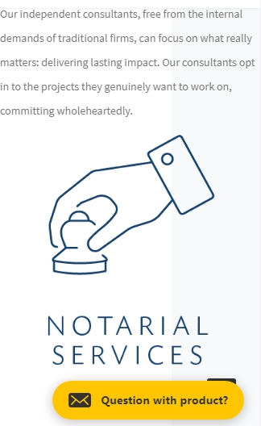

1. **LAYOUTS MENU**

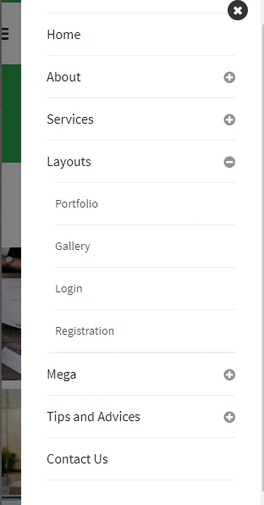

1. **PORTFOLIO PAGE**



**WHEN CLICK ONE OF THE AVAIABLE NOTARY :**

 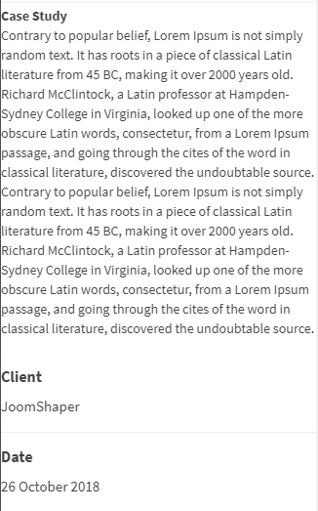

**WHEN SCROLL DOWN, WILL DESCRIBED HIS/HER CASE STUDY, CLIENT, and The DATE.**

1. **GALLERY PAGE**



1. **LOGIN PAGE**

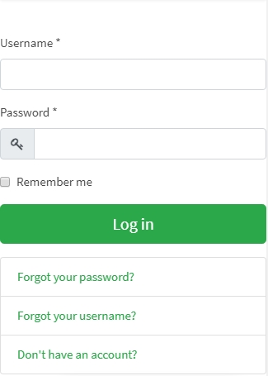

1. **Register Page**

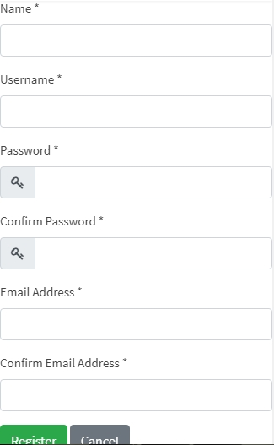

1. **CONTACT US PAGE**

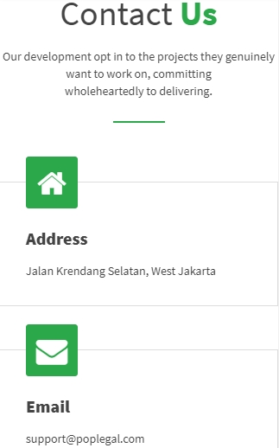

1. **WHEN CLICK “QUESTION WITH PRODUCT”, WILL APPEAR LIKE THIS :**

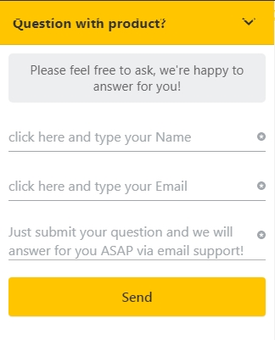

**WHEN FILLED ALL DATA :**

